Date: 9/23/2023

Reporter: Salam Younis

Product/Software Name: POS Store

Platform/Operating System:Web (React App)

Severity: Low

Summary:

Incorrect error message when entering an invalid price while adding a new product.

Description:

I encountered an issue while adding a new product in the POS Store application. When I entered the letter "e" in place of the price, I received a warning message that "Product Name is required".

Steps to Reproduce:

1.Log in as the admin user.

2.Go to the "Products" page.

3.Click the "Add Product" button.

4.Fill in the product details, including the price field.

5.Enter the letter "e" in place of the price.

6.Attempt to save the product.

Expected Behavior:

I expected that the program would detect the incorrect entry and show an appropriate error message informing me that the price field needs a numerical value.

Actual Behavior:

Instead of an error message about invalid input, I received a warning that the Product Name is required.

Screenshots/Attachments:

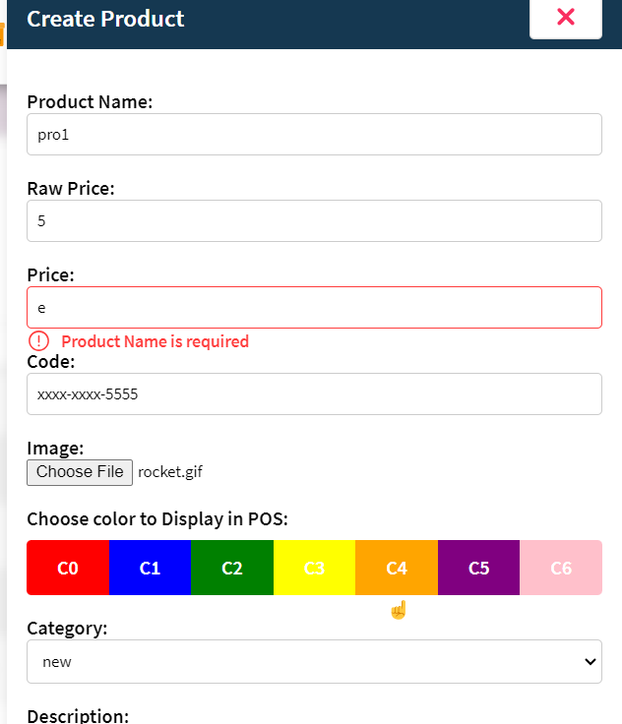

Date: 9/23/2023

Reporter: Salam Younis

Product/Software Name: POS Store

Platform/Operating System:Web (React App)

Severity: Medium

Summary: issue with adding new carts , two carts are created instead of one.

Description:

Encountered an issue while using the POS Store application's cart management feature. When attempting to add a new cart, the application sometimes creates two carts simultaneously, instead of the expected behavior of adding just one.

Steps to Reproduce:

1.Log in as the admin user.

2.Go to the POS page.

3.Click the "+" button to add a new cart.

4.Expected Behavior:

5.Expected that when clicking the "+" button, the application would create only one new cart.

Actual Behavior:

On some occasions, when clicking the "+" button, the application creates two new carts simultaneously, resulting in an unintended duplication of carts.

Screenshots/Attachments:

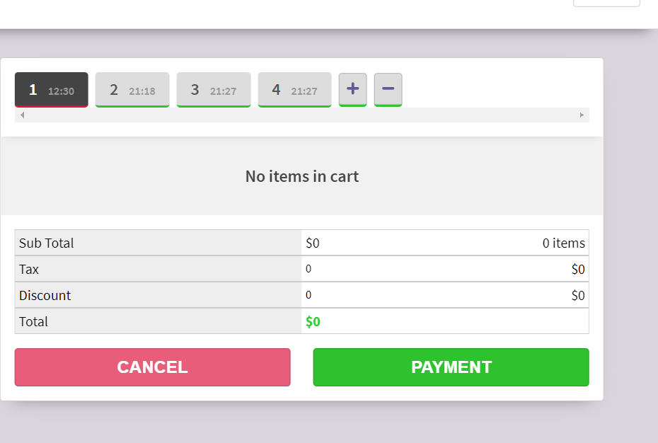

Date: 9/23/2023

Reporter: Salam Younis

Product/Software Name: POS Store

Platform/Operating System:Web (React App)

Severity: Medium

Summary:Search functionality on the products page does not work unless the filter button is clicked.

Description:

Encountered an issue on the products page of the POS Store application. When attempting to search for an item, the search functionality does not work unless the filter button is clicked.

Steps to Reproduce:

1. Log in as the admin user.

2. Go to the "Products" page.

3. Attempt to search for a product by name without clicking the filter button.

Expected Behavior:

Expected that the search function would work without needing to click the filter button, providing search results as I type.

Actual Behavior:

The search function only works after clicking the filter button, which is not intuitive and can cause confusion for users trying to search for products.

Screenshots/Attachments:

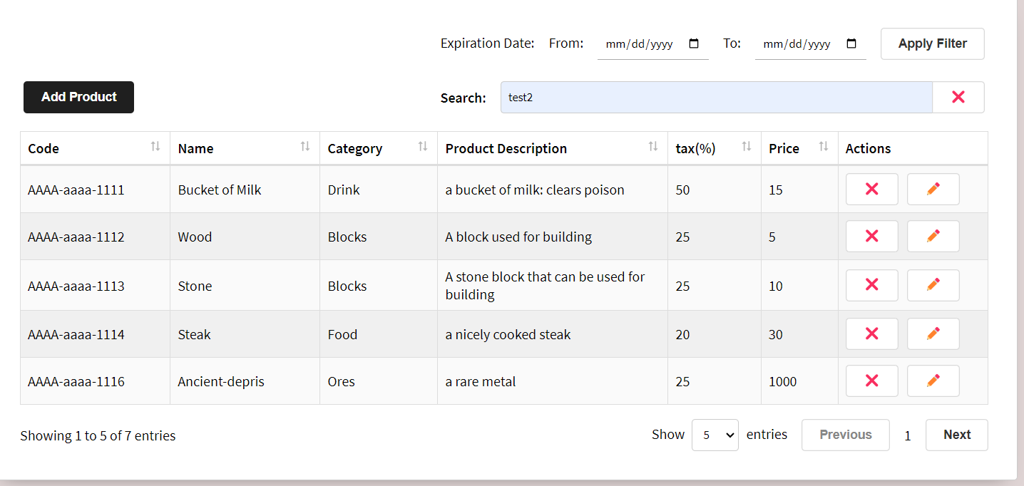

Date: 9/23/2023

Reporter: Salam Younis

Product/Software Name: POS Store

Platform/Operating System:Web (React App)

Severity: High

Summary: Payment button does not perform any action.

Description:

Encountered an issue in the POS Store application's cart management feature. When attempting to process a payment by clicking the payment button, it does not trigger any action.

Steps to Reproduce:

1. Log in as the admin user.

2. Go to the POS page.

3. Add products to the cart.

4. Click the "Payment" button to process the payment.

Expected Behavior:

Expected that clicking the "Payment" button would initiate the payment process and complete the transaction.

Actual Behavior:

Clicking the "Payment" button does not result in any action or progress in the payment process. It remains unresponsive.

Screenshots/Attachments:

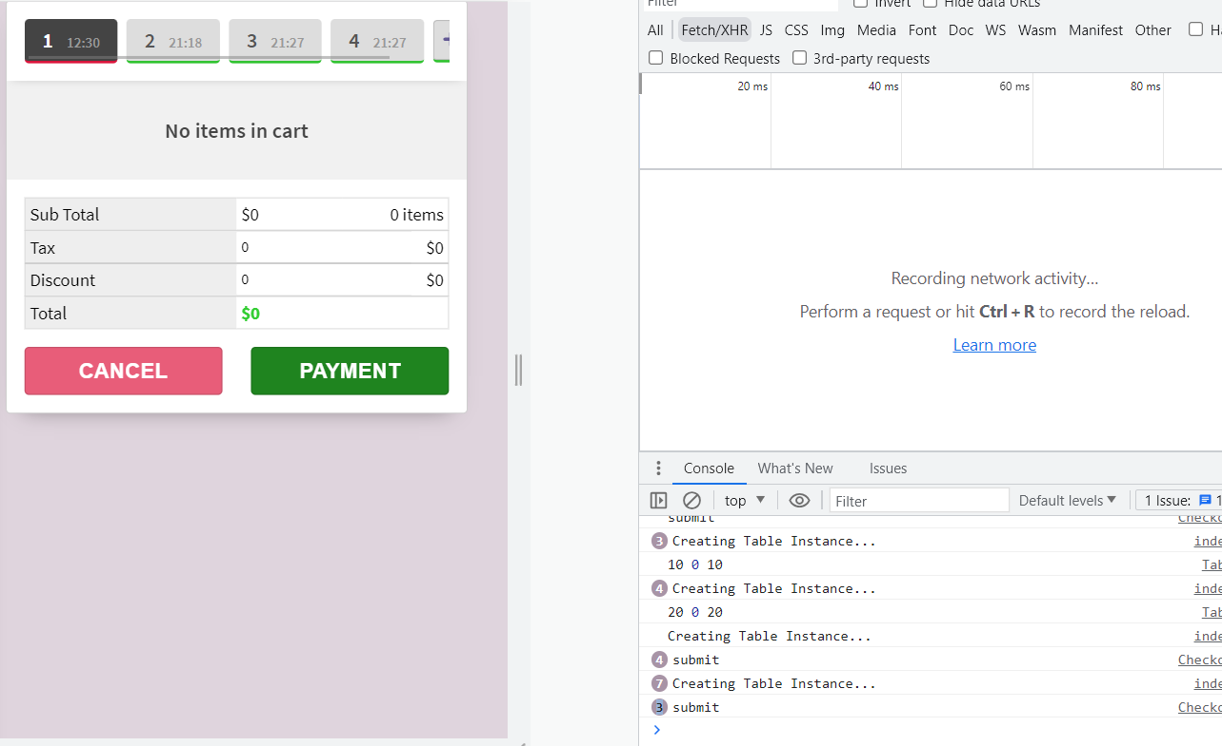

Date: 9/23/2023

Reporter: Salam Younis

Product/Software Name: POS Store

Platform/Operating System:Web (React App)

Severity:Low

Summary:Missing "From" and "To" date fields when adding a new product, but they exist when filtering (applying filter).

Description:

we noticed an inconsistency in the POS Store application when adding a new product. The "From" and "To" date fields are missing when adding a product, even though they exist when filtering (applying filter) on the products page.

Steps to Reproduce:

1. Log in as the admin user.

2. Go to the "Products" page.

3. Attempt to add a new product.

4. Observe that the "From" and "To" date fields are missing.

Expected Behavior:

we expected to see the "From" and "To" date fields when adding a new product, as they are important for tracking product information.

Actual Behavior:

The "From" and "To" date fields are not present when adding a new product. However, they are visible when applying a filter.

Screenshots/Attachments:

